ps

PERA CHALLENGE 2018
OCTOBER 27th,28th 2018

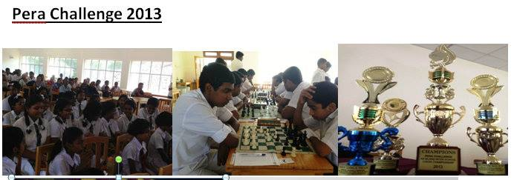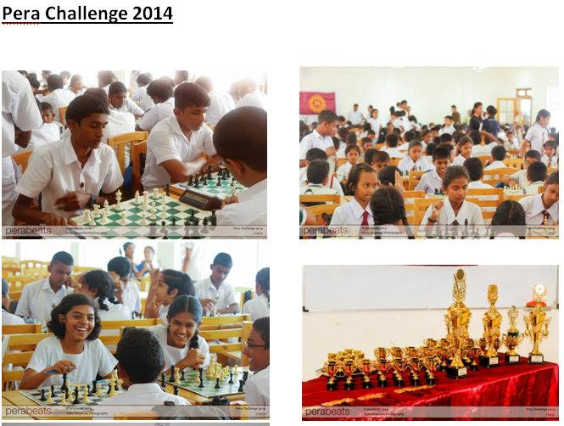

PERA CHALLENGE 2015 PERA CHALLENGE 2016
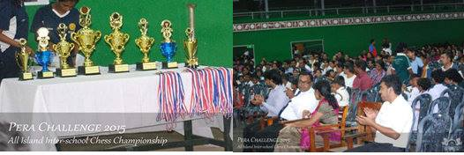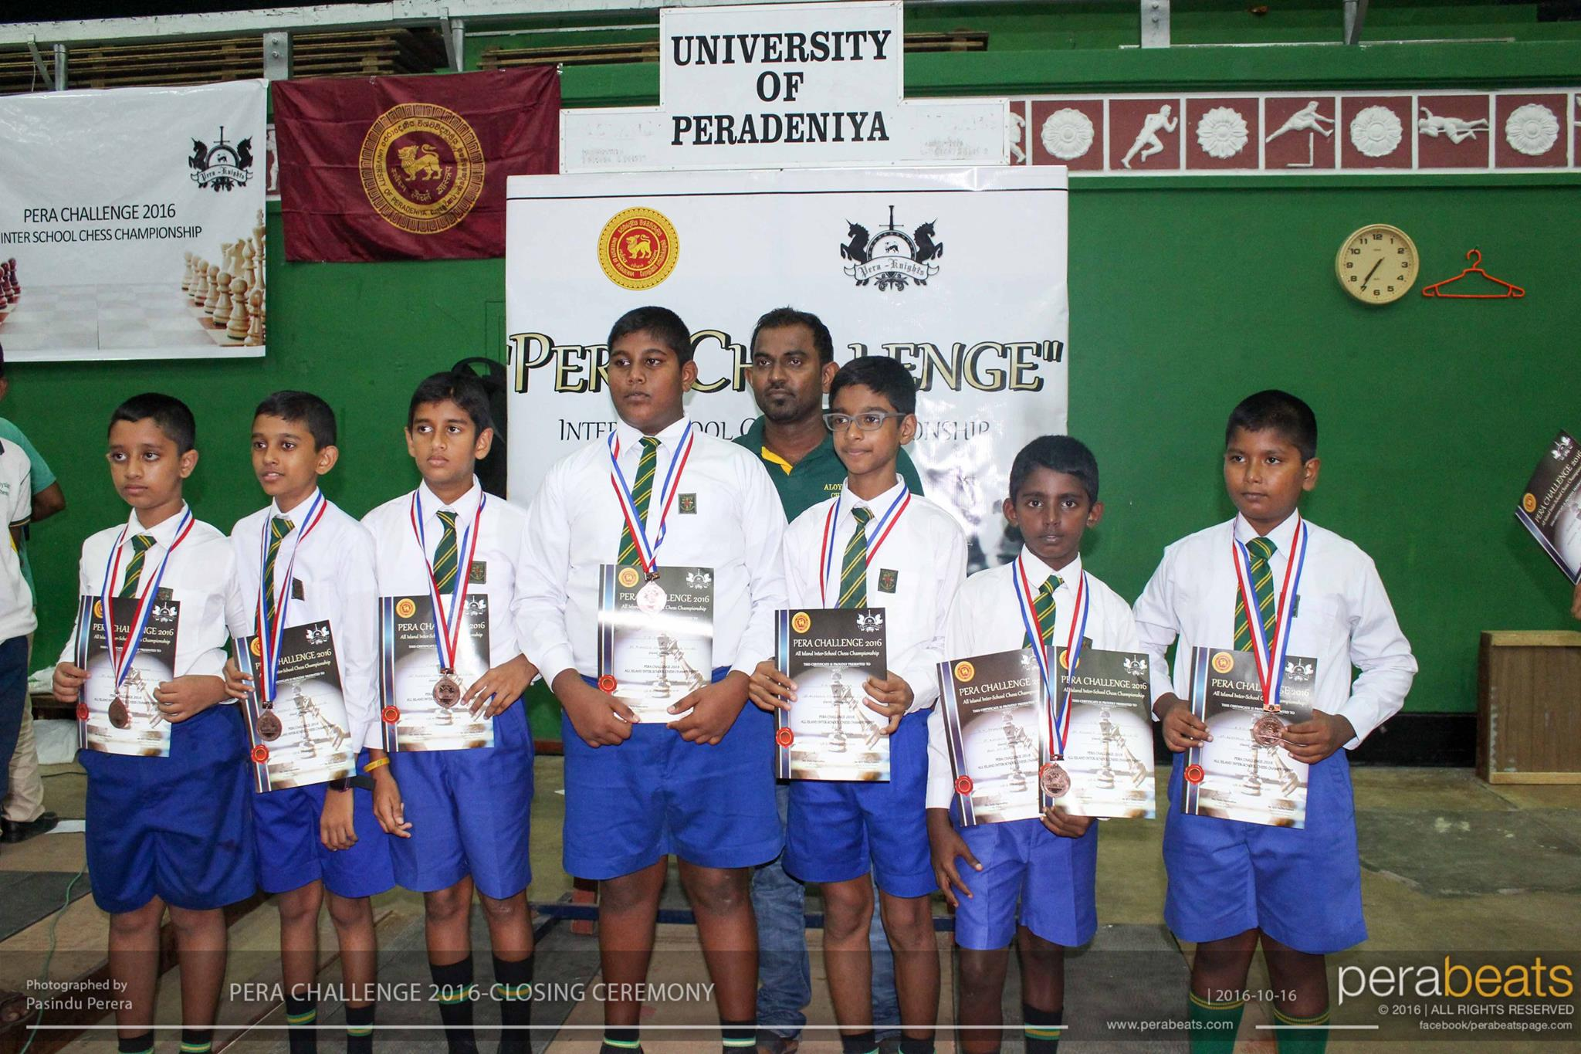

PERA CHALLENGE 2017
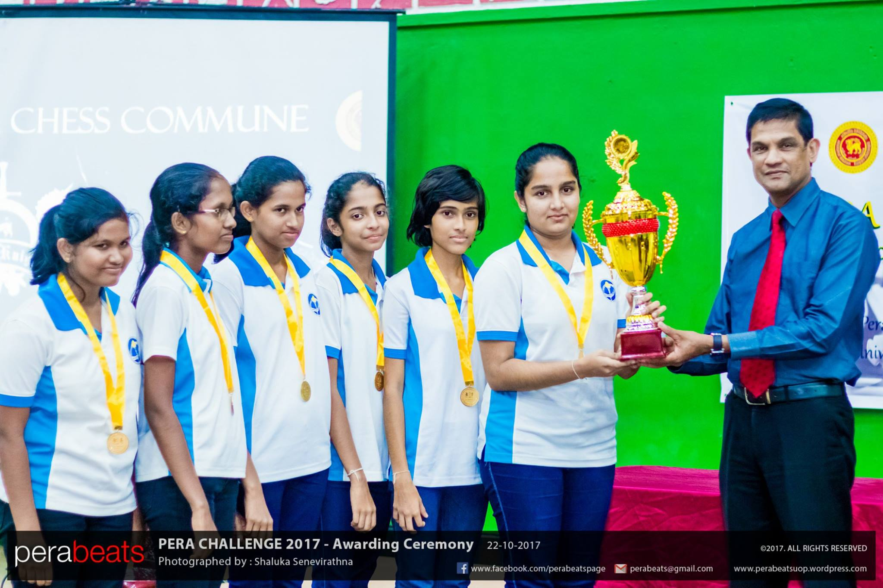

Photo Credits – perabeats
Dear Sir/Madam,

The Chess Commune and the Department of Physical Education of the University of Peradeniya will be organizing the annual All Island interschool Chess Championship-PERA CHALLENGE.
This is being held for the sixth consecutive year. This will be a team event which is open for girls and boys teams. We are pleased to extend our invitation to the budding chess players.

TOURNAMENT DETAILS
The tournament will consist of five categories
- U-09 OPEN, all students should be below 09 years on 31.12.2018
- U-11 OPEN, all students should be below 11 years on 31.12.2018
- U-13 OPEN, all students should be below 13 years on 31.12.2018
- U-15 OPEN, all students should be below 15 years on 31.12.2018
- U-20 OPEN, all students should be below 20 years on 31.12.2018

SCHEDULE
27th October 2018 – Rounds 1-3
28th October 2018 – Rounds 4-6 and Prize Distribution Function

All teams should be present at the venue by 7.30a.m. on 27th October 2018

VENUE
- Under 9,11,13 - Gymnasium, University of Peradeniya.
- Under 15,20 - Faculty of Management, University of Peradeniya (Near the gymnasium)
- Accommodation will not be provided in the University premises
TOURNAMENT REGULATIONS
- A Maximum number of 2 teams are allowed to take part from a school in each category.
- Each team should consist of seven players (6 players + 1 reserve)
- 6 Rounds – Swiss System
- Time Control
- Under 9,11,13 - 2 hours per game

- Under 15,20 - 3 hours per game
- Tie Breaks
- Match Points
- Sonneborn-Berger Tie Break
- Game Points
- Players are requested to bring their personal chess sets and clocks

- Any appeals/protests must be made before the commencement of the next round

- Organizers reserve the right to decline any late appeals/protests

- In the event of a dispute, the Chief Arbiter’s decision will be the final decision.

AWARDS
U20 OPEN - Champion U20 BEST GIRLS TEAM - Champion

1st Runners-up 1st Runners-up

2nd Runners-up 2nd Runners-up

U15 OPEN - Champion U15 BEST GIRLS TEAM - Champion

1st Runners-up 1st Runners-up

2nd Runners-up 2nd Runners-up

U13 OPEN - Champion U13 BEST GIRLS TEAM - Champion

1st Runners-up 1st Runners-up

2nd Runners-up 2nd Runners-up
U11 OPEN - Champion U11 BEST GIRLS TEAM - Champion

1st Runners-up 1st Runners-up

2nd Runners-up 2nd Runners-up

U09 OPEN - Champion U09 BEST GIRLS TEAM - Champion

1st Runners-up 1st Runners-up

2nd Runners-up 2nd Runners-up

- Certificates, medals and trophies will be awarded to the above mentioned places
- Certificates , medals and cups will be awarded to the board prize winners in each category
- Certificates of participation will be awarded to all players
- A team can claim only one prize even if they are eligible for two prizes

ENTRY FEE – Rs. 3500 per team

REGISTRATION

- Registration can be done by sending a copy of the entry form (attached with this letter) and a copy of the bank slip pertaining to the entry fees with the name of the school and age group/s clearly written on the bank slip. These can be sent through email or WhatsApp. Bank account details and contact details are given below.
- Registration Deadline – 21st October 2018 12 midnight
- It should be noted that the names in the entry forms will be used in the certificates.
- It is also advisable to use the same names in the team card.

BANK DETAILS
Bank-People's Bank
Account- SPORTS COUNCIL OF THE UNIVERSITY OF PERAA Account Number - 057-2-001-2-0029195

Email – perachesscommune@gmail.com

WhatsApp - 0714642473 - Yasas Lamawansa

For further details,
Yasas Lamawansa – 0714642473

Rasika Samaranayake – 0716159748 / 0778190558

ENTRY FORM
PERA CHALLENGE 2018

School : ……………..................................................................................

Name of the Team : ……………………………………………………………………….

Age Group: …………….. Boys/Girls

 | NAME | DATE OF BIRTH | SIGNATURE
1
2
3
4
5
6
7

….….………………………………….
Principal

